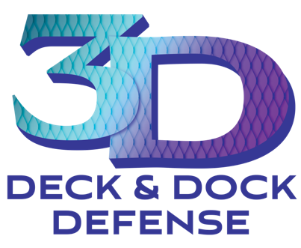
3D™ COATING
ACRYLIC POLYMER DECK, DOCK + CONCRETE COATING

Description
3D Deck & Dock Defense™
is an acrylic polymer coating that is environmentally friendly,
VOC free, and non-toxic. 3D resurfaces and revives old decks, docks, porches, and concrete surfaces.
Benefits
- ﻿﻿Safe—locks down splinters and prevents slipping
- ﻿﻿Durable—creates a durable, easy to maintain surface that lasts several years and prevents UV rays from penetrating the surface
- ﻿﻿Decorative—unlimited color choices to coordinate with any decor
- ﻿﻿Economical—a fraction of the cost of replacing old boards on decks, docks, and porches
Preparation
- ﻿﻿﻿Surface must be dry, clean and free of debris before coating is applied. We recommend
18% or less in moisture content.
- ﻿﻿﻿Apply the primer after stirring it with rollers or sprayers straight from the bucket. Let primer dry.
Mixing Instructions

- With a clean 5-gallon bucket empty one gallon of stain into the bucket. Add 1 gallon of Top Coat to the stain. Mix well until a consistent color is achieved (30 seconds).
- ﻿﻿﻿While mixing add the aggregate into the stain and Top Coat. Mix thoroughly until a smooth, creamy coating is achieved (1 to 2 minutes). You are now ready to apply the product.
- It should be noted that only Sherwin Williams Super Deck Solid 9600 Series stain or H&C Heavy Sheild Concrete Sealer should be used while mixing the product. Super deck for wood substrates H&C for Concrete

Installation
- ﻿﻿﻿After taping off cut in areas, using brushes, cut in along areas with one heavy coat and feathering leading edge.
- ﻿﻿﻿Using a 3/4-inch nap paint roller, apply first heavy coat against the grain of the surface trying to fill in all cracks and checks.
DO NOT continue to back roll over the coat that has just been applied especially in warmer weather or the aggregate will pull up and create an undesirable finish
- ﻿﻿﻿After first coat is dry (typically 30 minutes-1 hour), mix kit same as above and apply second coat rolling with the grain of the wood. Allow 24 hours after 2nd application before area can be walked on, 48 hours for furniture.
- ﻿﻿﻿Seal unused material in container and store in cool dry area.

Application
3D Coating Kit—liquid Top Coat, liquid Primer, aggregate in a poly bag. 1kit will cover roughly 100-200 sqft of surface once properly mixed

You will also need the following:
- ﻿﻿1 gallon of Sherwin Williams Super Deck 9600 Series OR H&C Heavy Shield in the color of your choice
- ﻿﻿An electric drill with a grout-mixing attachment
- ﻿﻿Paint rollers (3/4 nap recommended)
- ﻿﻿Paint brushes
- ﻿﻿Painter's Tape
- ﻿﻿Drop Cloth
- ﻿﻿5-gallon buckets

Environmental Certification
3D™ is a green certified low voc water based product that will not harm the environment. All products are water-based, which is essential when working over bodies of water and on boat docks and marinas.
Our products are manufactured by Green Down Stream Products, LLC and are backed by the expertise of chemists with over 30 years in the coatings industry.

Storage & Shelf Life
We recommend storing in sealed containers at < 80° F for no longer than 8 months.

Bo Hutchison
Owner/Operator
Atlantic Surface Solutions LLC
(843)-654-1380 Office Phone
Bo@atlanticsufacesolutions.com

